1. Which are the top three variables in your model which contribute most towards the probability of a lead getting converted?

**Answer:** The top 3 variables in the model contributing the most towards the probability

of a lead getting converted are as follows:

1. Lost to EINS (From Tags)
2. Welingak Website (From Lead Source)
3. Reference (From Lead Source)

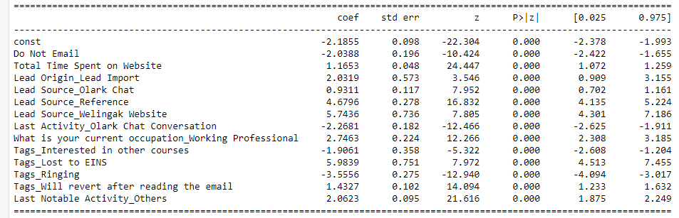

1. What are the top 3 categorical/dummy variables in the model which should be focused the most on in order to increase the probability of lead conversion?

**Answer:** As could be referred from the abovescreenshot, the top 3 features which

should be focused upon the most on, in order to increase the probability of lead

conversion are:

1. Welingak Website (From Lead Source)
2. Refence (From Lead Source)
3. Working Professional (From What is your current occupation)

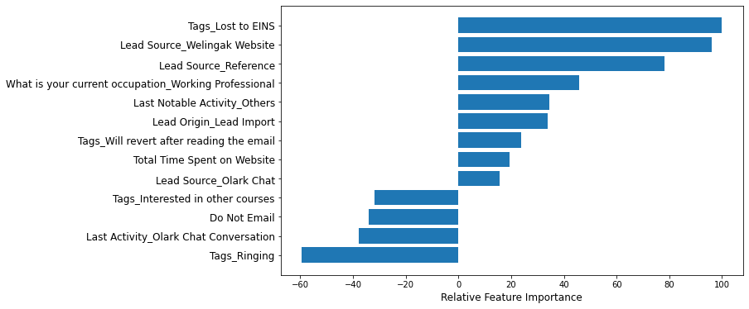

1. X Education has a period of 2 months every year during which they hire some interns. The sales team, in particular, has around 10 interns allotted to them. So during this phase, they wish to make the lead conversion more aggressive. So they want almost all of the potential leads (i.e. the customers who have been predicted as 1 by the model) to be converted and hence, want to make phone calls to as much of such people as possible. Suggest a good strategy they should employ at this stage.

**Answer:** The best strategy is to focus on working professionals, focusing in order first

Welingak Website leads, then those who have high Total Time Spent on

Website,and finally through leads that came in through Olark Chat.

1. Similarly, at times, the company reaches its target for a quarter before the deadline. During this time, the company wants the sales team to focus on some new work as well. So during this time, the company’s aim is to not make phone calls unless it’s extremely necessary, i.e. they want to minimize the rate of useless phone calls. Suggest a strategy they should employ at this stage.

**Answer:** In this condition they should focus more on other methods like automated

emails, SMS, video messaging, unconventional methods that may take longer

time to perfect. In addition to trying out these strategies they can try to work on

the lesser correlated features.